[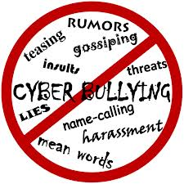](http://www.google.co.uk/imgres?q=cyber+bullying&num=10&hl=en&safe=active&biw=1280&bih=841&tbm=isch&tbnid=1EeBftzT0aFZSM:&imgrefurl=http://info.uknowkids.com/blog/bid/159164/Global-Perspective-on-Cyberbullying&docid=l_CEft-X0bEcqM&imgurl=http://info.uknowkids.com/Portals/176530/images/cyberbullying.jpg&w=2433&h=2433&ei=-Xt1UNaPPIml0QXoz4DYCg&zoom=1&iact=hc&vpx=709&vpy=455&dur=67&hovh=225&hovw=225&tx=82&ty=163&sig=103403135367689647427&page=1&tbnh=149&tbnw=149&start=0&ndsp=22&ved=1t:429,r:13,s:0,i:112)