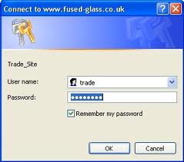
Secure Passwords
In class you discussed the rules that everyone should follow when choosing a password to protect access to your user area, your social networking account or your mobile phone.
Below is a quick reminder of those rules:
- Do not choose things such as your dog’s name or your favourite football team
- Try to use nonsense words rather than something straight out of the dictionary
- Try to remember your password, do not write it down
- Make your password at least six characters long
- Use a mix of letters, numbers, symbols and upper and lower case letters
- Do not use the same password for everything
- Keep your password a secret – not even your best friend should know it
- Do not use something obvious like ‘password’
Homework Task
Using the rules above, create a poster that could be displayed in your ICT classroom to help remind all students (and teachers!) about the rules to follow when choosing a new password.
- Have a clear title
- Make the rules easy to read and understand
- Make the poster eye-catching through the use of colour and/or images
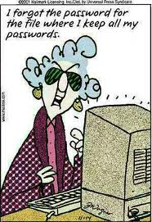
- Have one or two large images rather than lots of tiny ones
The poster can be done either on the computer or by hand.

